Probability vs. Statistics

Different subjects: both about random processes

Probability

* Logically self-contained
* A few rules for computing probabilities
* One correct answer
* More mathematical, more fundamental

Statistics

* Messier and more of an art
* Get experimental data and try to draw probabilistic conclusions
* No single correct answer
* Application of probabilty

Counting: Motivating Examples

What is the probability of getting exactly 1 heads in 3 tosses of a fair coin?

Poker Hands

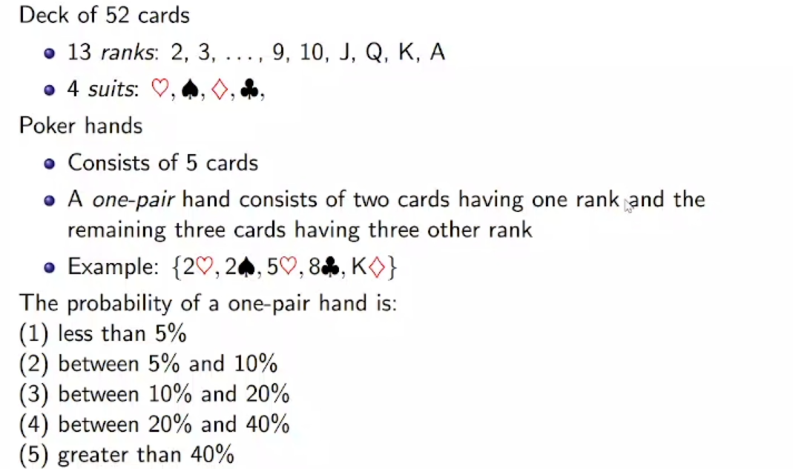

Sets in Words

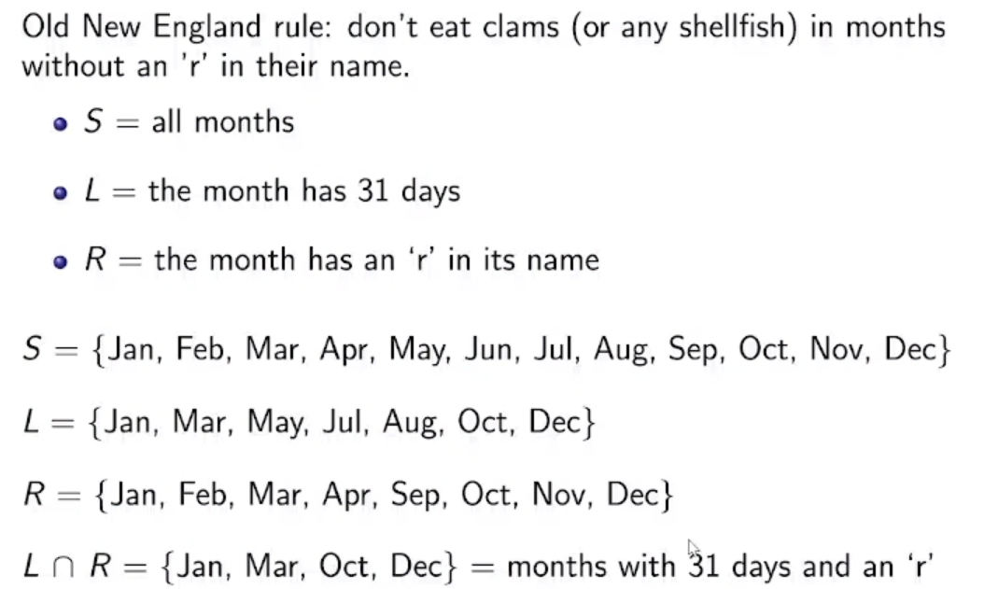

Sample space is just a set mathematically.

Set has some certain properties. It is not a random collection of things.

Visualize Set Operations with Venn Diagrams

Intersection elements will be counted twice if you count the numbers. When you write as a set, you write them once.

U 🡪 cup 🡪 cap

Product of sets (we increase the dimension):

Inclusion-Exclusion Principle

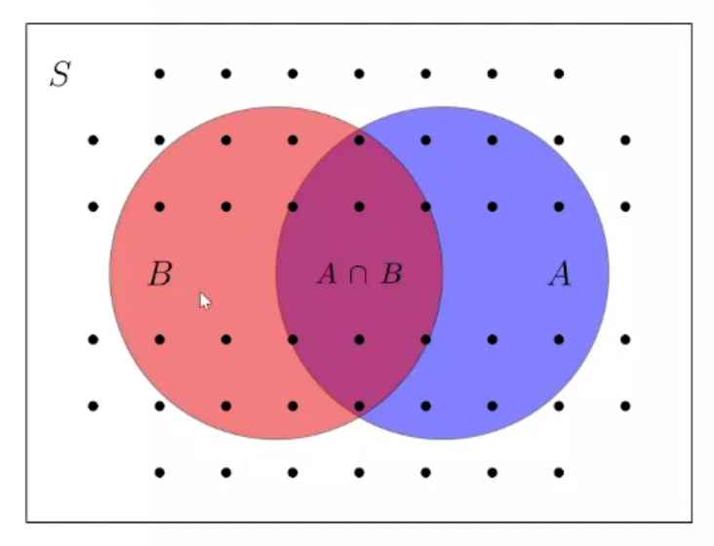

s(A U B) = s(A) + s(B) – s(A B)

Board Question

7 + 4 – 2 = 9

Rule of Product

3 shirts, 4 pants = 12 outfits

(More powerful than it seems.)

Concept Question: DNA

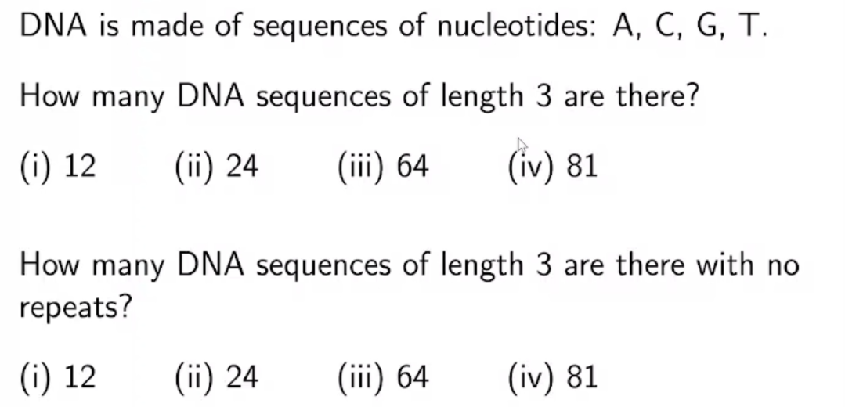

Board Question 1



Board Question 2

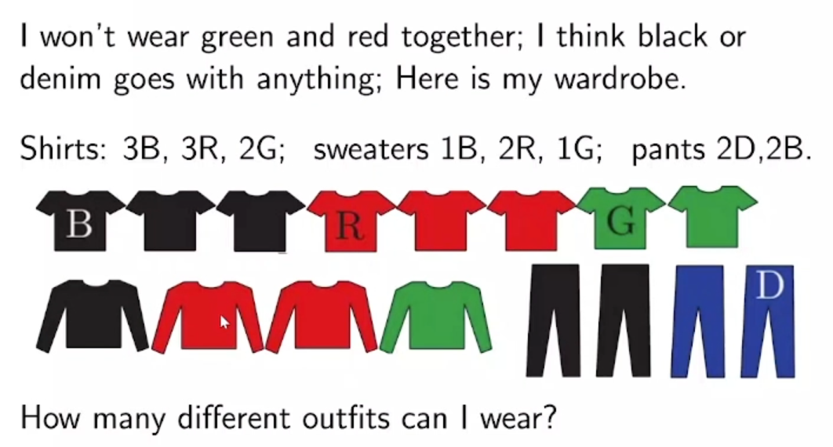

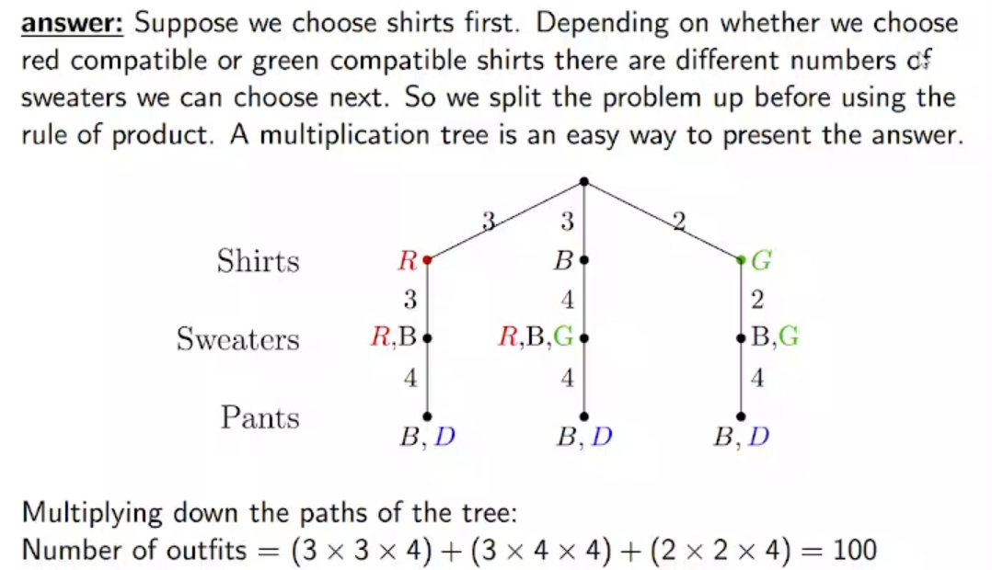

number of red shirts